VUS6.b Westward Movement – Review Questions

Use your notes to respond to these questions. Upload to your Google Folder when complete.

1. What does the term “Cotton Kingdom” refer to?

2. Why were Native Americans forced to move to Oklahoma?

3. What is this forced removal of the Indians called?

4. What is a reservation?

5. How did America acquire the territory that would become California, Nevada, Utah, Arizona, and parts of Colorado and New Mexico?

6. What does Manifest Destiny mean?

What do each of these images represent?

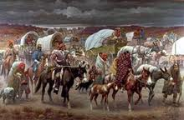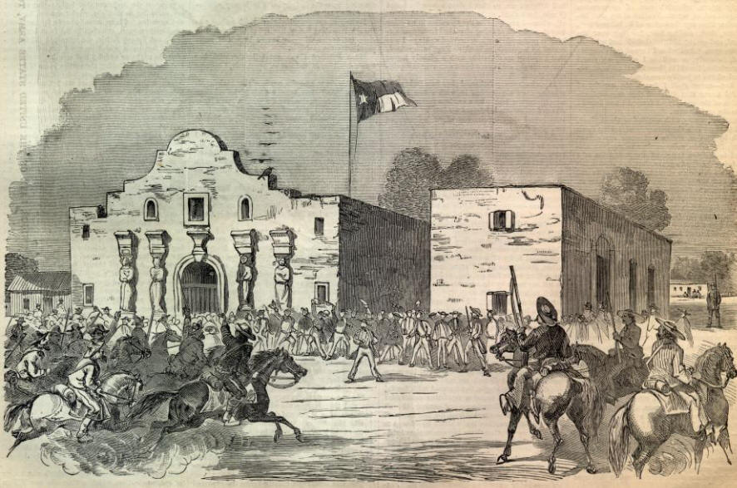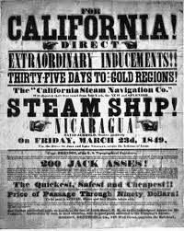

7._______________________ 8._______________________ 9._____________________

10. Why do you think some Americans thought it was OK to force the Native Americans off their land?

11. How do you think the railroads and canals helped westward expansion?

