Louisiana Purchase
C. Sacajawea, an American Indian woman, served as their guide and _____________.
A. Thomas Jefferson, as president in 1803, __________the huge Louisiana territory from France, which _________ the size of the United States overnight.

B. He authorized the Lewis and Clark expedition to explore the new territories that lay west of the ______________ ________.

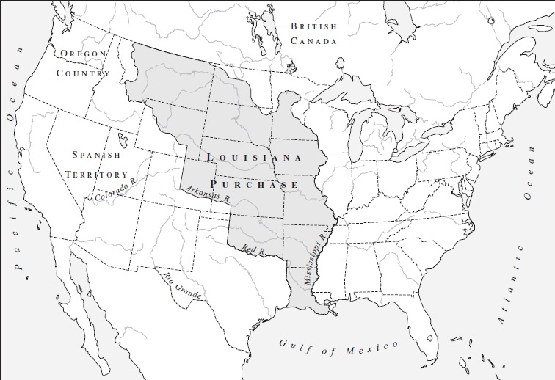

War of 1812

Causes

British ____________ with American shipping and western expansionism fueled the call for a declaration of war.

America needed to fight the British again as ___________ sought parts of Canada, an end to British _________ of sailors, and an end to British agitation of Indians in the West.

War Hawks – Young and militant ____________ of the Democratic-Republican party.

- wanted _________ policies against the British.

Impressment – British Navy _________ American citizens at sea and forced them to serve the British Navy.

Federalists opposed Madison’s war resolution and talked of __________ and proposed constitutional amendments that were not acted upon.

Important Events

Battle of New Orleans – Andrew Jackson __________ the city with a small army against the British.

- Battle actually took place after the peace treaty was signed.

- Jackson gained ________ as a War Hero.

Fort McHenry and Francis Scott Key

- The fort withstood a ____ hour naval bombardment.

- Key observed the battle aboard a British ________ ship.

- the events ________ the writing of “The Star Spangled Banner.”

The Outcomes

Treaty of _______ ended the hostilities.

American victory established the nation’s _________ in the Western Hemisphere.

- This would help shape American ________ policy.

- US gained the Oregon Territory which would spur ________ into the Western Territories.

The Monroe Doctrine

The Americas should not be considered for future colonization by European Powers.
Nations in the Western Hemisphere were inherently different from those of Europe (republics rather than monarchies).

The U.S. would regard any European attempt to “meddle” in the Western Hemisphere as a threat to peace and safety.

The U.S. would not interfere in European affairs!

