**VUS 11c Minorities & Woman in WWII Notes Name:________________________**

**Still Seeking Equality:**

**African Americans and others struggled to obtain**

**desegregation of the armed forces and end discriminatory**

**hiring practices on the home front.**

**World War II solidified the**

**nation’s role as a global**

**power and ushered in social**

**changes and established**

**reform agendas that would**

**preoccupy public discourse in**

**the United States for the**

**remainder of the 20th**

**century.**

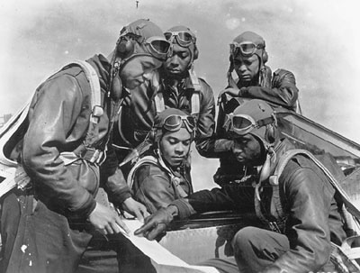

Japanese

Americans in

WWII

• ***Nisei*** regiments (Japanese

Americans) earned a high

number of decorations.

• They served in segregated

units and were restricted to

fighting only in Europe.

• Many felt the need to prove

that they were loyal to

America, rather than to Japan.

African-Americans in

WWII

Women in

WWII

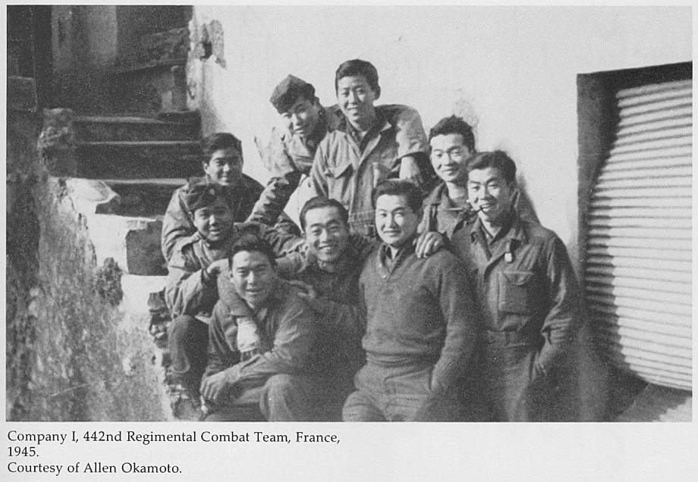

*They flew approximately 15,553*

*sorties, and completed 1,578*

*missions protecting the 12th*

*Tactical and 15th U.S. Army Air*

*Force bomber squadrons over*

*Italy and Germany. These*

*courageous men came home*

*with 150 Distinguished Flying*

*Crosses, a Legion of Merit, 744*

*Air Medals, 8 Purple Hearts, two*

*Soldier Medals, 14 Bronze Stars,*

*and a Red Star of Yugoslavia.*

*The Tuskegee Airmen destroyed*

*or damaged over 409 German*

*aircraft.*

**Women entered into previously**

**male job roles**

**Women increasingly joined the**

**Armed services- in support roles**

**rather than combat.**

**+ African Americans generally**

**served in segregated military**

**units**

**+ Most were assigned to**

**non-combat roles but**

**demanded the right to**

**serve in combat rather**

**than support roles.**

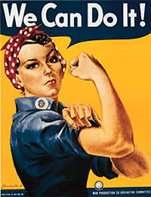

The Navajo Code Talkers in action in the

Pacific. Their language was never “cracked”

by the Japanese. Without their special skills,

many more Americans would have perished

in the Pacific! (National Archives)

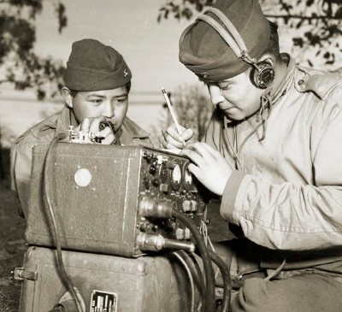

**Navajo Code Talkers**:

Communication codes

of the Navajo were

used in the Pacific.

• Navajo language was

oral, not written, and

was impossible for

Japanese to break.

Critical Thinking:

How did minorities contribute to an allied victory?

How did the contributions of minorities help in future Civil Rights movement?

Other Contributions:

-Mexican-Americans fought in non-segregated units

- Woman joined all branches of armed forces to serve their country

Costs of their Contributions:

-Minority units suffered higher casualties

-Units and individuals won numerous awards and individual medals for bravery and valor

**How did minority participation in**

**World War II reflect social**

**conditions in the United States?**

• Segregation was the law of the South, and the U.S. government maintained this philosophy through the war.

• Minority soldiers had “tasted” equality in Europe, and they would demand social change when returning home.

• Experiences in war would help to usher in a new Civil Rights Movement