VUS. 11d Geneva Convention, POW’s, Holocaust

The Geneva Convention attempted to ensure the humane treatment of prisoners of war by establishing rules to be followed by all nations.

The treatment of prisoners of war in the Pacific Theater often reflected the savagery of the fighting there.
- In the Bataan Death March, American POWs suffered brutal treatment by the Japanese after surrender of the Philippines.
- Japanese soldiers often committed suicide rather than surrender.
The treatment of prisoners of war in Europe more closely followed the ideas of the Geneva Convention.

Holocaust
- genocide: The systematic and purposeful destruction of a racial, political, religious, or cultural group
- final solution: Germany/Hitler’s decision to exterminate all Jews

Affected groups
- Jews
- Poles
- Slavs
- Gypsies
- Catholic Priests
- “Undesirables” (homosexuals, the mentally ill, political dissidents)

Significance
- In the Nuremberg trials, Nazi leaders and others were convicted of war crimes.
- The Nuremberg trials emphasized individual responsibility for actions during a war, regardless of orders received.
The trials led to increased demand for a Jewish homeland.
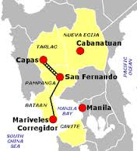
Map of Bataan Death March

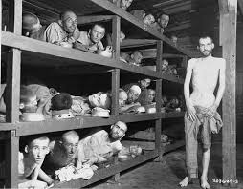
Jews living in deplorable conditions in a
Concentration camp

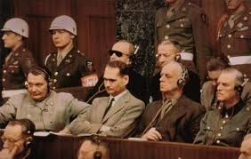
German officers charged with war crimes
Listen to translated proceedings at Nuremburg.

