Missouri Compromise

The stricter fugitive slave law inflamed abolitionist opinion and exacerbated sectional differences.

California was admitted as a free state to take advantage of the gold found there.

Events moved too rapidly during the 1850s to assess the effectiveness of other elements of the compromise.

The issue of slavery would be decided by popular sovereignty in Kansas and Nebraska.

“Bleeding Kansas” was the result. This was a kind of mini-Civil War fought out by proslavery and antislavery people who moved to Kansas to participate in the vote about slavery.

-All Missouri was to enter as a slave state, and Maine was to enter as a free state. A line was to be drawn along the southern border of Missouri, and the extension of slavery into territories north of this line was to be forbidden.

-It provided an uneasy yet essentially workable approach until the 1850s. In the Dred Scott decision of 1857, Chief Justice Roger Taney declared the Missouri Compromise unconstitutional.

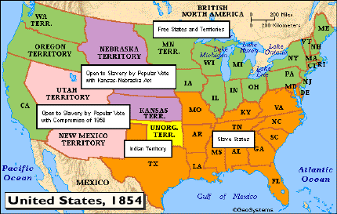

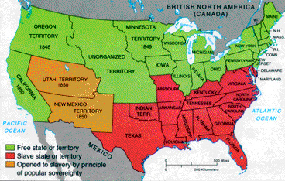

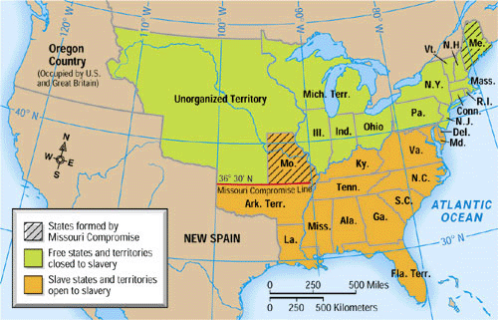

Compromise of 1850-

California would enter as a free state.

The issue of slavery would be decided by popular sovereignty in Utah and New Mexico territories.

Slave trade (but not slavery) would be abolished in the District of Columbia.

A stricter fugitive slave law would be put into effect.

Kansas-Nebraska Act-

How was the issue of slavery going to be handled in the newly organized territories of Kansas and Nebraska?

Missouri Compromise-

Missouri wanted to enter the Union as a slave state. This would have upset the balance of free and slave states in the Senate. What was to be done?